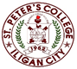

***Committed to Excellence***

St. Peter’s College

042 Sabayle St., Iligan City

**COLLEGE OF COMPUTER STUDIES (SEMINAR AND TOURS)**

**NARRATIVE REPORT ON SEMINAR (WEB-DEV BACKEND)**

On the afternoon of March 2, 2024, at around 1:45 pm, the 4th-year students gathered in the computer laboratory, Room A203, for a seminar by Ms. Catherine Maglasang. By 2:00 pm, once everyone was present, the seminar began with a prayer and a brief introduction of the speaker and her expertise.

Ms. Catherine discussed Web Development Backend using Python. She shared her experiences, current work, focus areas, and the company she works for. She also talked about the high demand for Django, a popular framework, and mentioned her café in Abuno, Iligan City, which also offers web development services specializing in backend development. Additionally, she shared her experiences on starting to work both physically and remotely, emphasizing the importance of building a portfolio and other work-related essentials.

By around 3:00 pm, the seminar was nearing its end. We asked various questions related to backend development. After the Q&A session, we took photos with Ms. Catherine as the seminar concluded.

Prepared by:

Edward Jr A. Cabello

       Student

Checked by:

MELLANIE S. GAMBE, MSIT

Dean, College of Computer Studies

Reviewed & Approved by:

MELLANIE S. GAMBE, MSIT

Dean, College of Computer Studies

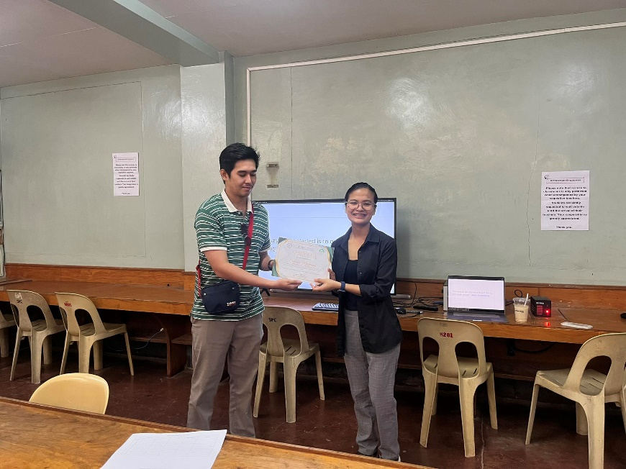

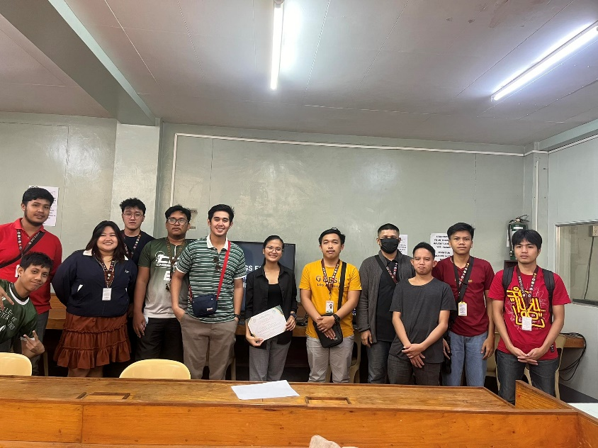

Left: Giving out Certificate to speaker.

Right: Group Photo along with the Speaker Ms.Catherine.